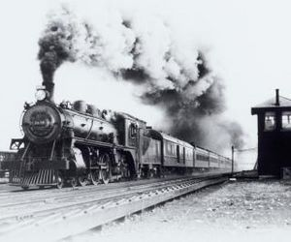
steam (Photo: Hemera Technologies/AbleStock.com/Getty Images)

Steam Engine
While James Watt cannot take full credit for the steam engine, because of many precursors, he developed the first reliable one. The steam engine, developed over the second half of the 18th century, became the engine for the Industrial Revolution. Steam engines were the power behind locomotives and ships, which provided a faster source of transportation to bring raw materials to factories and to bring finished products to market. Watt is also credited with the term "horsepower" to describe the amount of energy a steam engine could create.
While James Watt cannot take full credit for the steam engine, because of many precursors, he developed the first reliable one. The steam engine, developed over the second half of the 18th century, became the engine for the Industrial Revolution. Steam engines were the power behind locomotives and ships, which provided a faster source of transportation to bring raw materials to factories and to bring finished products to market. Watt is also credited with the term "horsepower" to describe the amount of energy a steam engine could create.

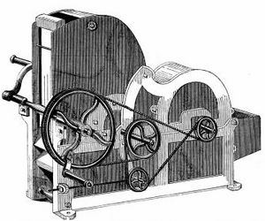
gin (Photo: Photos.com/Photos.com/Getty Images)

Cotton Gin
Eli Whitney invented the cotton gin in 1794 and is credited with spurring enormous growth in America's cotton industry. The cotton gin sped up the process of extracting seeds from cotton and made the crop viable for farmers and investors. Although the cotton gin was designed to alleviate the intensive work it to took to separate the seeds from the cotton, it had the unintended effect of increasing the number of slaves needed to harvest the cotton crop.

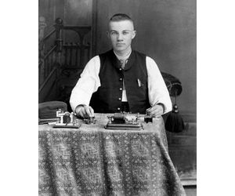
telegraph (Photo: Jupiterimages/Comstock/Getty Images)

Telegraph
The telegraph is the precursor to almost all of the world's communications. In 1832, Samuel Morse, who gave his name to the Morse code, deduced that messages could be sent over wire while sailing home to New York. Morse, in 1835, unveiled a working prototype for the telegraph to friends and colleagues. Over the next 100 years, the telegraph became the standard means of communication over long distances.

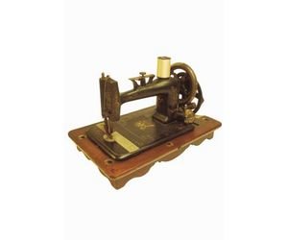
sew (Photo: Ablestock.com/AbleStock.com/Getty Images)

Sewing Machine
Although the sewing machine does not seem like a revolutionary invention, it is what the printing press was to books, an invention that sped up a thousandfold the processing of textiles into marketable goods. Elias Howe was awarded a patent in 1846 for the first commercially viable sewing machine.
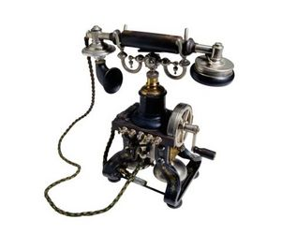
phone (Photo: Ryan McVay/Photodisc/Getty Images)

Telephone
"Mr. Watson, come here, I want to see you" is one of the most famous quotes from the Industrial Revolution and signaled a new era in communications. Alexander Graham Bell is credited with inventing the telephone in 1876, although some historians say Elisha Gray, a competitor of Bell, was the first to submit his telephone design to the U.S. patent office. No matter the true origins of the telephone, it connected the world like no other invention until the Internet.

bulb (Photo: Comstock Images/Comstock/Getty Images)

Light Bulb
As with the steam engine and sewing machine, Thomas Edison did not invent the light bulb; Humphry Davy is credited with creating the first light bulb in 1809. But Edison created the first viable incandescent light by using a carbon filament and low electrical current inside a glass bulb. This invention paved the way for the worldwide spread of electricity.
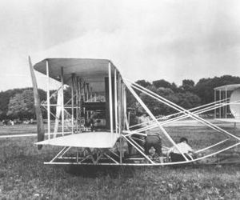
plane (Photo: Photos.com/Photos.com/Getty Images)

Airplane
The invention of the airplane added to the theme of "faster is better" that was so much a part of the Industrial Revolution. As the steam engine had accelerated production and trade, the airplane would eventually help globalize the world. Orville and Wilbur Wright, at the dunes of Kitty Hawk, are credited with the world's first sustainable flight. Their simple biplane spurred a nation's curiosity, which eventually led man to conquer the skies.

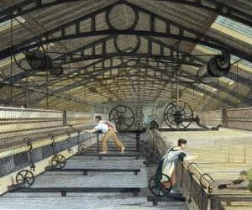
line (Photo: Photos.com/Photos.com/Getty Images)

Assembly Line
Though it can be argued that the assembly line is more an idea than an invention, it may be what most people think of in connection with the Industrial Revolution. Henry Ford became rich and famous by developing a means of mass production for his Model T automobile. By creating a line where each worker had a specialized task that culminated in the assembly of an entire vehicle, Ford found he speeded up production and lowered cost. The assembly line became the standard means for production in the world.

